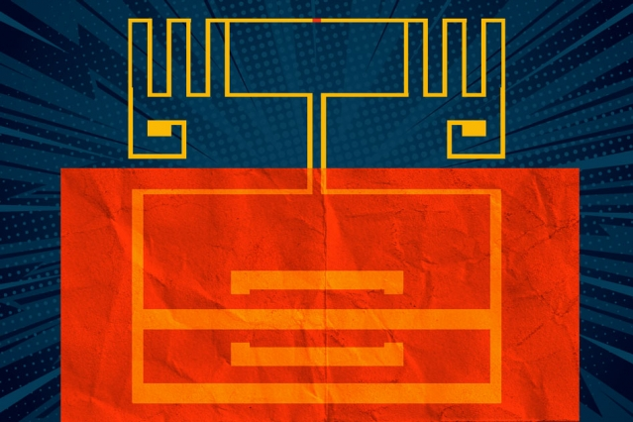

Converting Wi-Fi signals to electricity with new 2-D materials

A device made from flexible, inexpensive materials could power large-area electronics, wearables, medical devices, and more.

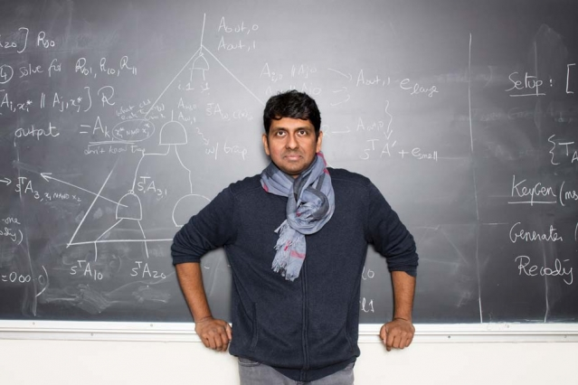

Fortifying the future of cryptography

EECS Professor Vinod Vaikuntanathan aims to improve encryption in a world with growing applications and evolving adversaries.

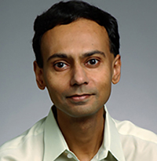

EECS professor to receive Distinguished Alumnus Award

Srinivas Devadas will be honored by the Indian Institute of Technology Madras.

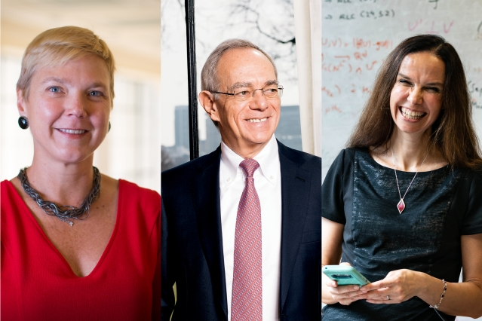

Three at MIT named 2018 fellows of the National Academy of Inventors

MIT President Rafael Reif and two engineering faculty members are recognized for significant contributions to quality of life, economic development, and the welfare of society.

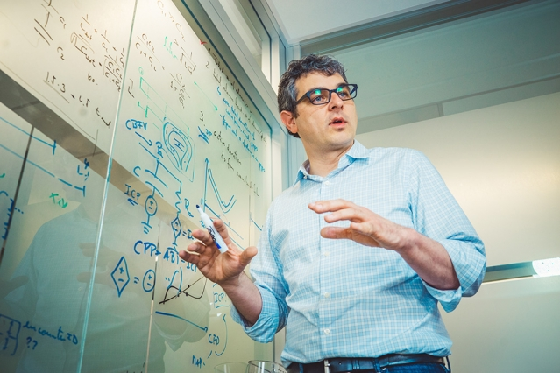

Thomas Heldt named IEEE EMBS 2019 Distinguished Lecturer

The EECS faculty member will serve a one-year term in the Engineering and Medicine and Biology Society program.

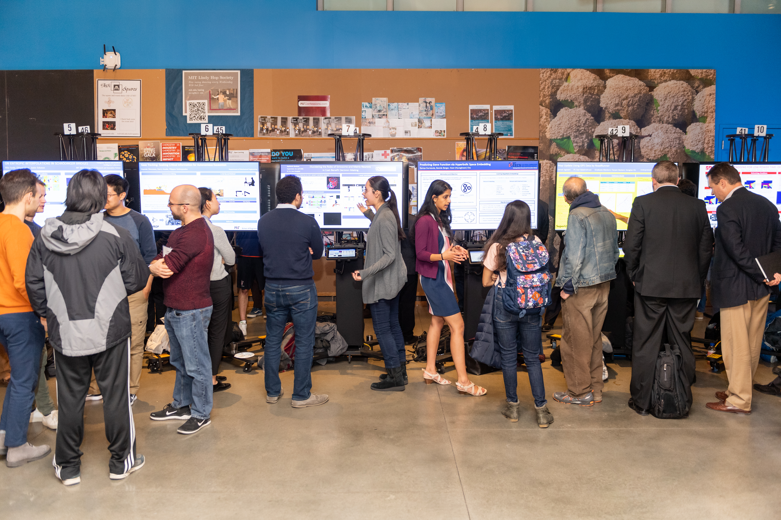

EECS announces six new faculty members

The new professors are among 11 joining several School of Engineering departments.

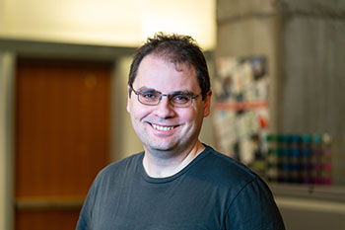

SuperUROP: Showcasing students' research work in progress

Undergraduate researchers discussed their projects at a well-attended poster session, followed by the annual SuperUROP Community Dinner.

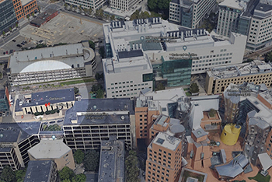

Aleksander Madry on building trustworthy artificial intelligence

The EECS faculty member spoke during a recent MIT symposium exploring methods for making artificial intelligence systems more reliable, secure, and transparent.

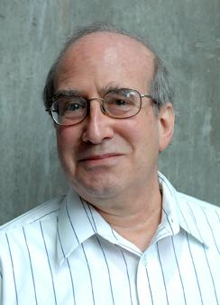

Building site identified for MIT Stephen A. Schwarzman College of Computing

The headquarters would replace Building 44, forming an “entrance to computing” near the intersection of Vassar and Main streets.